|  |  |  |  |  |
| --- | --- | --- | --- | --- |
|  | **Title :** **Project Registration & Progress Review** | | **FF No. 180** |  |
|  | | | | | |
|  | | | | | |
| **Department:** Information Technology | | **Academic Year:** 2025-26 | | | |
| **Semester:** I | | **Group No.: 1** | | | |
| **Project Title:** Fracture Detection from Mobile-Captured X-rays | | | | | |
| **Project Area:** Fracture Detection, X-ray Images, Mobile Capture, AI, CNN, Medical Imaging,  Transfer Learning, TensorFlow Lite, Healthcare AI, Image Classification | | | | | |
| **Group Members Details:** | | | | | |

|  |  |  |  |  |  |  |
| --- | --- | --- | --- | --- | --- | --- |
| Sr. No. | Class & Div. | Roll No. | G.R.No. | Name of Student | Contact No. | Email ID |
| 1 | TY IT B | 63 | 12420018 | Purva Balasaheb Patil | 8552916059 | purva.patil24@vit.edu |
| 2 | TY IT B | 64 | 12420021 | Maheshwari Virendra Ishvarshette | 8999316902 | maheshwari.ishvarshette24@vit.edu |
| 3 | TY IT B | 69 | 12420068 | Somanath Sidharam Birajdar | 9403545312 | somanath.birajdar24@vit.edu |
| 4 | TY IT B | 71 | 12420079 | Payal Pandurang Tuptewar | 8799941731 | payal.tuptewar24@vit.edu |
| 5 | TY IT B | 73 | 12420092 | Ghansham Ashok Pawar | 9767380225 | ghansham.pawar24@vit.edu |

|  |
| --- |
| Name of Internal Guide: prof. Deepali Jadhav Contact No.: 90111 17215 Email ID:deepali.jadhav@vit.edu |

|  |
| --- |
| Project approved / Not approved  Prof. Deepali S. Jadhav Prof. Gurunath T. Chavan Prof. (Dr.) Sachin R. Sakhare  **Guide Project Coordinator Head of Department** |

T

**FF No** **180**

**Project Synopsis**

1. **Introduction:**

Fractures pose the second most common orthopedic condition demanding acute and accurate diagnosis. In the past, X-ray scans were done by radiologists using high quality images captured by a good medical equipment. But in many areas where digital health technology is slow on the uptake, patients turn to hard copies of X-ray films and paper files or WhatsApps photos for consultations.

Recognize common mistakes in chest X-rays, ideally matched to the MRI standard and captured via mobile camera on a day-to-day basis against varying lighting, background noise, perspective which know from feedback is kill to quickly diagnose by doctors.

By combining the power of artificial intelligence (AI) with image processing, auto detection of fractures from images captured on mobile phones can resolve this issue and provide quick, dependable and ubiquitous diagnosis.

1. **Review of Literature:**

**[1] Pranav Rajpurkar, Jeremy Irvin, et al., “CheXNet: Radiologist-Level Pneumonia Detection on Chest X-Rays with Deep Learning” (2017)**

This finding led to the development of CheXNet, a deep CNN for chest X-ray analysis and demonstrated that deep learning could be feasible in radiology with potential implications to further extend these methods to fracture detection tasks.

**[2] Henrique Oliveira, et al., “Automated Wrist Fracture Detection using Transfer Learning with ResNet” (2018)**

It is of note that some authors used transfer learning with ResNet on the MURA dataset to detect wrist fractures achieving high classification accuracy.

**[3] X. Liu, et al., “Multi-view Convolutional Neural Networks for Bone Fracture Classification” (2019)**

Proposed a multi-view CNN method which is able to capture the information over multiple X-ray views for better classification and detection.

**[4] Q. Guan, et al., “Real-Time Bone Fracture Detection using YOLOv3” (2020)**

Implemented Real-time Fracture Detection using YOLOv3: Shows promise for being integrated with mobile based diagnostic systems.

**[5] S. Chung, et al., “DenseNet for Musculoskeletal Radiographs” (2020)**

Deployed DenseNet with 276,241 images for multiple musculoskeletal radiographs demonstrating resilient localization power on different skeletons and injury levels.

**[6] S. Yahalomi, et al., “AI-Based Pediatric Fracture Detection: Accuracy Compared to Expert Radiologists” (2021)**

Conducted a study assessing the diagnostic performance of AI in detecting pediatric fractures and found that AI results were comparable to those of expert radiologists.

**[7] J. Kim, et al., “Lightweight CNN for On-Device Fracture Detection” (2021)**

Created a lightweight CNN for edge devices that allow mobile-based fracture detection with as little as 50 ms inference time.

**[8] Y. Wang, et al., “Attention-Based CNN for Fracture Region Localization” (2022)**

Implemented attention mechanism in CNNs to pay more attention on the region of fracture, facilitates better clarity and diagnostic accuracy.

**[9] H. Shen, et al., “Enhancing Low-Quality Mobile-Captured X-Rays for AI Diagnosis” (2022)**

Proposed enhancement techniques for low-quality mobile X-raysenance, improving AI model performance over resource-limited sites.

**[10] M. AlHussein, et al., “Hybrid Image Preprocessing and Deep CNN for Robust Fracture Detection” (2023)**

Deep CNNs when combined with image preprocessing, can boost the classification accuracy under harsh conditions especially in case of varying lighting and image noise.

1. **Problem Statement:**

Frequent bone fractures require early diagnosis of the injury. Maintainence of digital Mammography in rural or underresourced areas has limitations in access to radiologist, and residents may travel long distance for expert evaluation. X-ray machines, of course, are common but it takes experience to know how to interpret the images. When diagnosis is delayed, the patient may receive inappropriate treatment and slow recovery or could potentially suffer permanent harm. Providing a tool capable of rapidly performing virtual fracture diagnosis from imaging, even images captured by a mobile phone camera utilizing artificial intelligence, might translate to fewer delays in more definitive steps in patient care that could subsequently result into better patient outcomes.

1. **Objectives:**
2. An AI system that can detect bone fractures from X-rays, even if they are taken with a mobile phone camera.
3. Implemented deep learning techniques, including image preprocessing for biometrics data to allow for stable performance under different lighting conditions and viewing angles with various resolutions and high accuracy and resilience.
4. Deliver a quick and automated, point-of-need diagnostic resource for remote or under-resourced health care providers and patients.
5. Allow seamless integration with mobile or web platforms to detect fractures and generate reports.
6. Decrease diagnosis delay, and contribute to early medical intervention: reduce the risk of poor patient recovery outcomes.

**System Architecture:**

1. **System Architecture:**

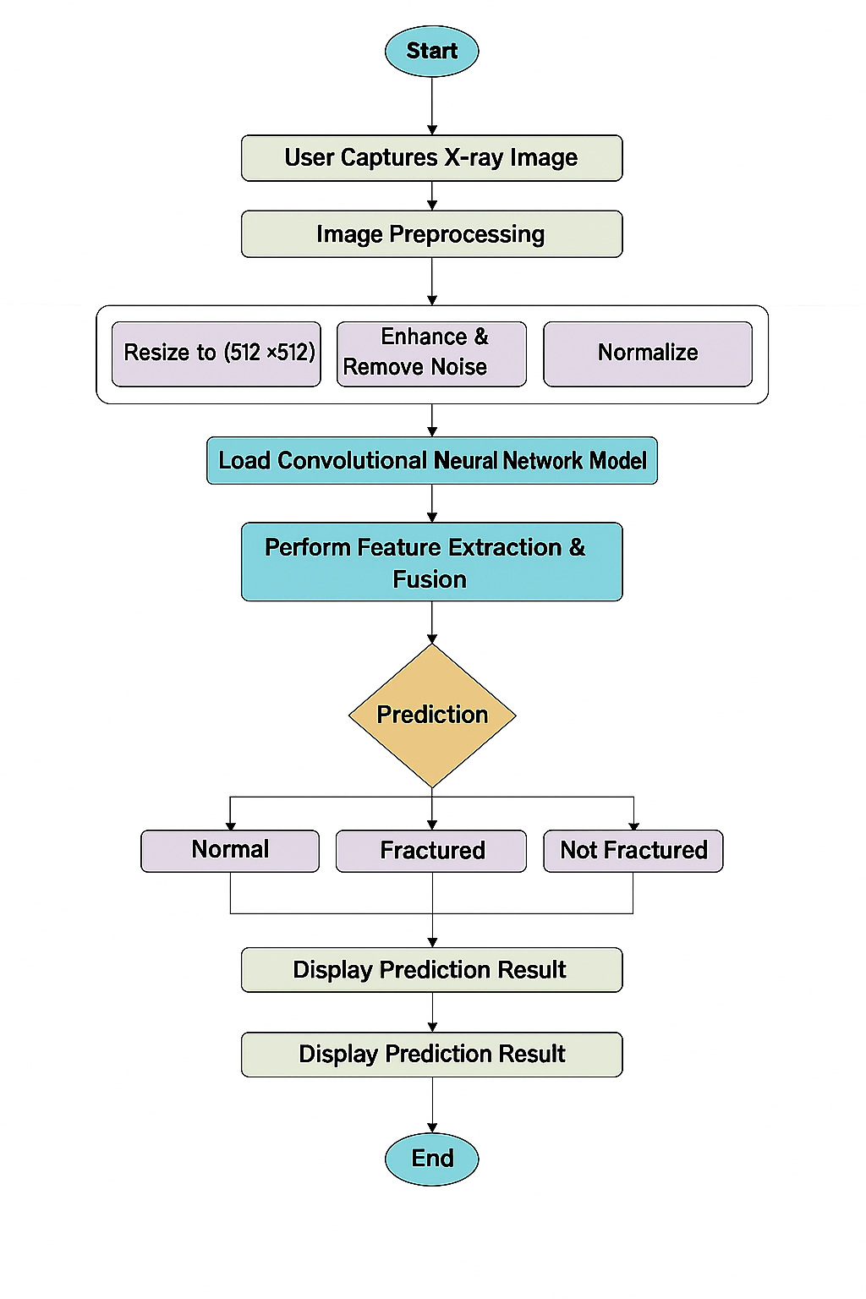

**FF No** **180**

|  |  |  |  |
| --- | --- | --- | --- |
| Group No. | 1 | | |
| Activity | Review Schedule | Progress Review Report submitted | Signature of Guide |
| Review 1 | Mid Sem. Semester | Yes / No |  |
| Review 2 | End of Semester | Yes / No |  |

Format of Progress Review Report:

|  |
| --- |
| **Review No.: 1 Group No.: Date:** |
| **Progress Review Report** |
| **Signature of Guide:** |

**FF No** **180**

|  |
| --- |
| **Review No.: 2 Group No.: Date:** |
| **Progress Review Report** |
| **Signature of Guide:** |